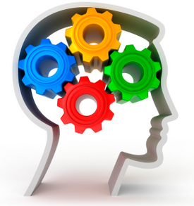
BRUBAKER BRAIN BOOSTERS
National Michigan Day – January 18

Directions: Listen to the information about Michigan and answer the questions after you have heard it.
Michigan has over 3,000 miles of freshwater shoreline – more than any other state. Its name comes from the Indian word Michigama that means great lake. Also known as the 'mitten state' because of its shape, Michigan has more than 11,000 inland lakes. Michigan also ranks sixth in the nation for its amount of forest land area.

What are 2 nicknames for the state of Michigan?

How long is Michigan's freshwater shoreline?

What is the origin of the name of Michigan?

What states are connected to Michigan?

There are 5 Great Lakes. Can you name them? To help, each letter in the word HOMES begins the name of a Great Lake.

For more tasks like this, see our product
Sourcebook for Receptive & Expressive Language Functioning
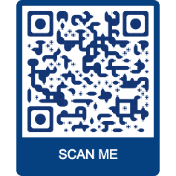
BRUBAKERBOOKS.COM

…Your trusted source for aphasia and cognitive treatment materials
for adults and adolescents.
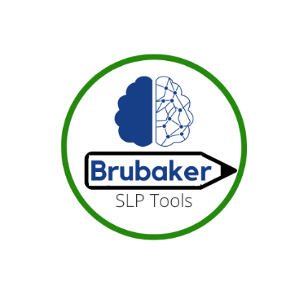
Follow us on Facebook and Instagram @ BRUBAKERSLPTOOLS
.

