BRUBAKER BRAIN BOOSTERS
Ugly Sweater Day

Directions: Julie, Carl, Liz and John won first through 4th place in an Ugly Sweater Competition. Read the sentences and figure out the winning order. Fill in their names on the lines below.

Liz was in 3rd place. The people whose names start with the same letter are not next to each other in placement. Carl’s win was one number higher than Julie’s.
Top 4 winners in the Ugly Sweater Contest
1. __________________________

2. __________________________

3. __________________________

4. __________________________

For more tasks like this, see our product Complex Challenges for Comprehension.
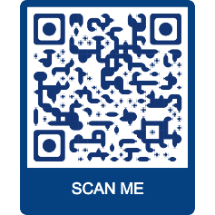
BRUBAKERBOOKS.COM

…Your trusted source for aphasia and cognitive treatment materials
for adults and adolescents.
Follow us on Facebook and Instagram @ BRUBAKERSLPTOOLS
.

