Tips and Tricks for Enjoying the Holidays Following Brain Injury

Holidays are a wonderful time to be with family and friends.

Brubaker Books wishes you happy and healthy holidays. We know communication and cognitive challenges can get in the way of many holiday events. We want you to enjoy your time with family and friends. Be flexible and open to modifying old traditions and starting new ones.

Please discuss the following Tips and Tricks with your Speech and Language Pathologist to optimize your experience.

- Plan or attend smaller gatherings rather than a larger one
- Plan or attend events when you have the most energy
- Prepare a script with questions to initiate conversation
- If a communication board is needed create a new one for the event
- Plan nonverbal activities for engagement such as cookie decorating, puzzles or games such as dominoes
- Have notes of current happenings with family and friends in attendance
- Prepare a notecard with the names of people at the event
- Find a quiet room to decrease overload or take a break from the excitement
- Find a quiet room for one-on-one conversations
- Have a snack available to keep your energy up
- Attend for short periods of time for example attend just for dessert
- Avoid back-to-back events
- Bring a game or puzzle to share
- Get together before or in place of the event to cook or decorate with family and friends
- Start your holiday shopping and cards early
- Know your strengths and weaknesses – pay attention to your brain
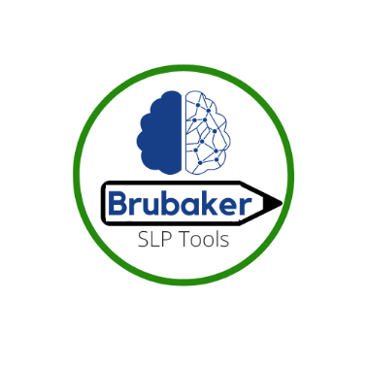
- Have a plan and stick to your plan!
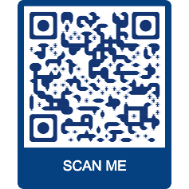
BRUBAKER BOOKS.COM
…Your trusted source for aphasia and cognitive
treatment materials for adults and adolescents
Follow us on Facebook and Instagram @ BRUBAKERSLPTOOLS

