BRUBAKER BRAIN BOOSTERS

National Sandwich Day

In honor of National Sandwich Day in November, here are some questions to exercise your brain.

Name 3 different sandwiches in alphabetical order or for a different challenge, list them alphabetically by their second letter.

Name 3 common sandwich ingredients beginning with the letter M.

Using 3 consecutive letters of the alphabet, name 3 common fillings used to make a sandwich.

Put together your idea of a great sandwich using 4 ingredients of different colors. Can you make a sandwich with all 4 ingredients of the same color?

Name 3 restaurants where you can buy a sandwich and list them in order from the least to most number of letters in their names.

For more tasks like this, see our product Flex Your Brain Cards

BRUBAKERBOOKS.COM
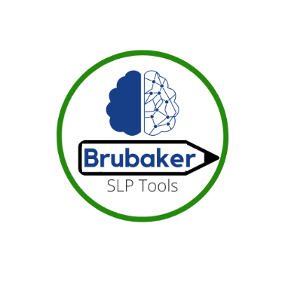
…Your trusted source for aphasia and cognitive treatment materials for adults and adolescents.
See us on Facebook and Instagram

