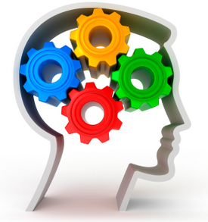
BRUBAKER BRAIN BOOSTERS
Memories from 2022

2023 is almost here. But let’s not forget 2022.
Below are questions based on your past year.

What was something you accomplished you thought you could not or you hadn’t tried before?
Who was someone you saw that you hadn’t seen in a while?
What was something you bought or acquired that you enjoyed using?
Finish the sentence: It was the year of _________________
What is a food memory (a good one and one not so delicious one) from the past year?
Which month in 2022 brings back a good memory?

For more tasks like this, see our product Communication Catalyst Cards.

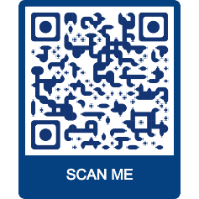
BRUBAKERBOOKS.COM

…Your trusted source for aphasia and cognitive treatment materials
for adults and adolescents.
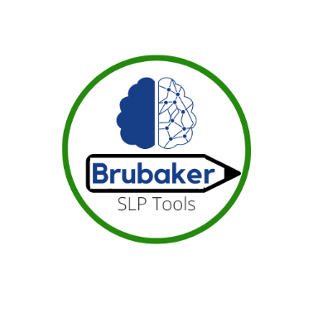
Follow us on Facebook and Instagram @ BRUBAKERSLPTOOLS
.

