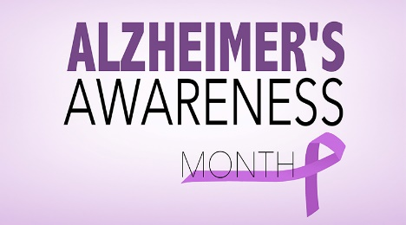
November is National Alzheimer’s Awareness month.
My mom has been diagnosed with Alzheimer’s type dementia and has been experiencing gradual decline over the past 5 or so years. Her inability to remember conversations, repeating questions she already asked, and losing familiar objects, etc is what keyed us in that something was wrong. Initially, more organization of belongings, a better calendar system and simple notes around the house was all she needed however now, after moving into an assisted living facility she requires much more. My specialty as an SLP was in dementia care at an outpatient setting giving me an advantage in helping my mom. I want to pass on some information and ideas I have learned over the years and in practice with my mom and my patients.
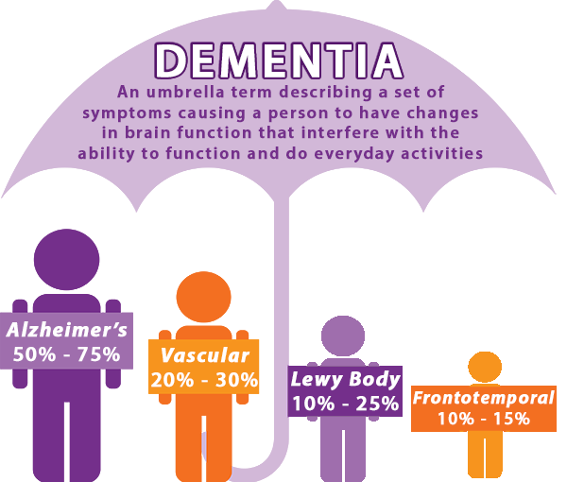
Here is a definition of dementia and can more easily explained using this diagram. Dementia is not a specific disease but is rather a general term for the impaired ability to remember, think, or make decisions that interferes with doing everyday activities. Alzheimer’s disease is the most common type of dementia. Though dementia mostly affects older adults, it is not a part of normal aging.

Alzheimer’s disease is a brain disorder that slowly destroys memory and thinking skills and, eventually, the ability to carry out the simplest tasks. For my mom, the onset of symptoms was rather slow and we had to be astute to when she was experiencing difficulties such as shopping or keeping track of appointments or cooking a meal so we could implement a strategy to help her manage. As caregivers, we need to be spies. I frequently looked in her frig to determine if food was spoiling or looked in her pill organizer to make sure medication was being taken or looked in her to see that clothes were being changed out. I even checked for a damp towel to see if she truly took a shower like she said. What a person with dementia says does not mean that is the truth. They state information as they know if but if they can’t remember then their memory fills in the gaps with what happened in days past or what would be expected. Trust but verify. This is a challenging concept.
Here are some photos showing strategies we implemented around my mom’s apartment.
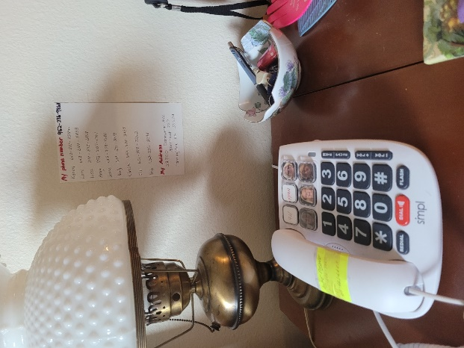
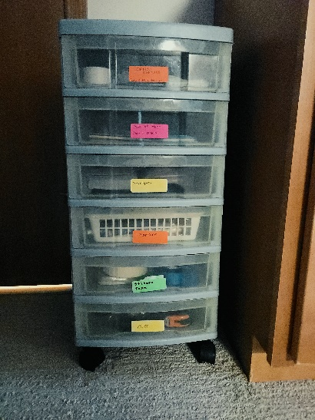
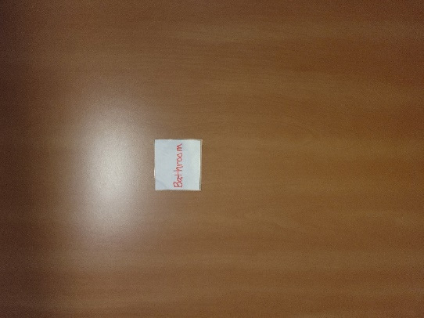
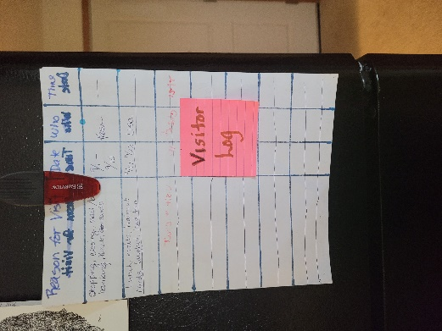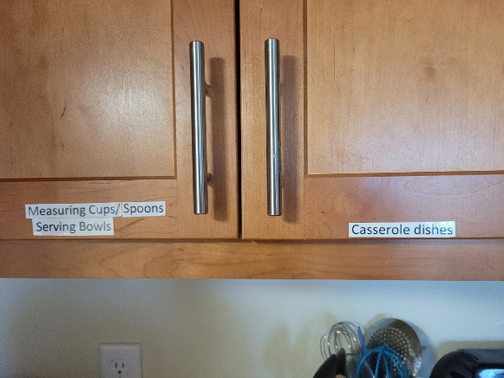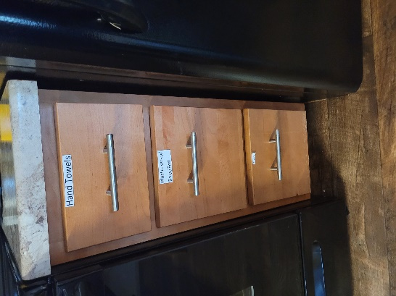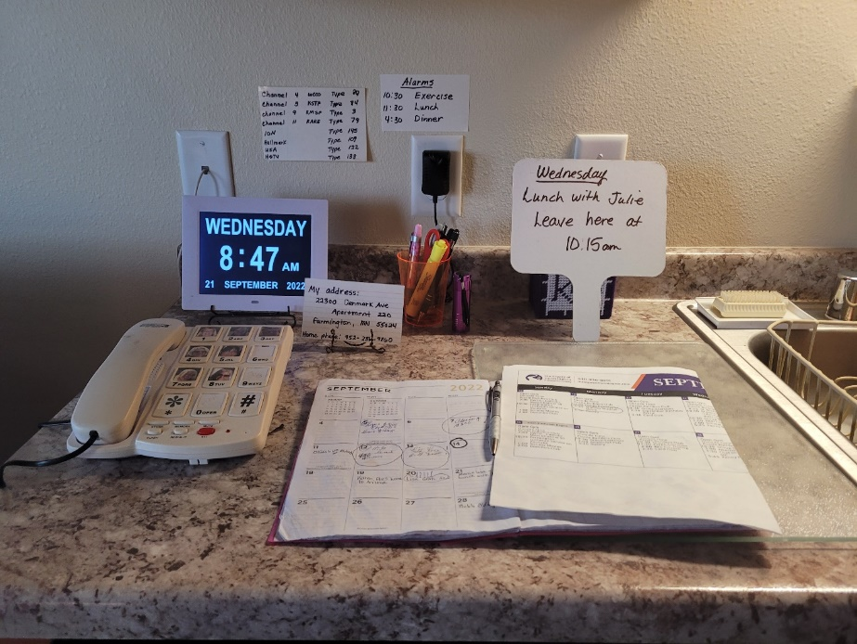
List of phone numbers by the phone, posted and not laying on a tabletop where it can be covered up by other items or papers. A picture phone can be helpful. Cell phones can become challenging to use so a landline may need to be considered.
Label kitchen cabinets, other drawers, rooms.
A visitor’s log reminds to person with dementia who visited and what did they do.
Create HOME CENTRAL where the calendar, phone, clock, pad of paper etc are kept for easy access.

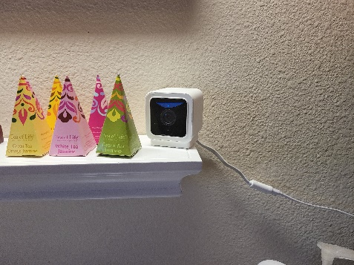
We installed a camera inside my mom’s home to keep track of what was happening. We learned valuable information and found it good for safety.
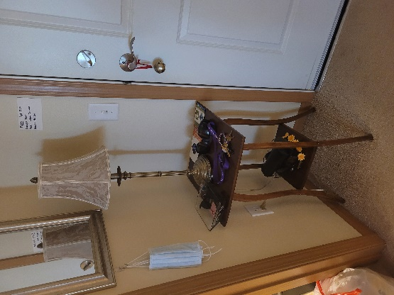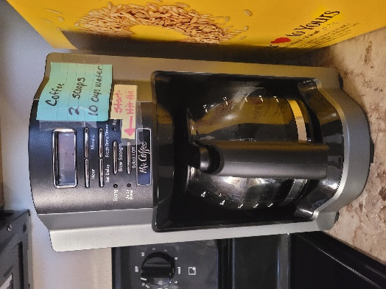
Post instructions on how to work an appliance, steps do doing laundry, etc on item itself.
A place by the front door for keys, wallet, purse, etc. Hooks are helpful.

