BRUBAKER BRAIN BOOSTERS
CELEBRATE SUMMER

Answer each description by writing one letter on each blank line. One letter of your answer has a number below it. Write that letter on the corresponding number at the bottom of the page. If you have answered correctly, a word will be spelled out that can also be associated with summer. Need a hint? All of your answers can be associated with SUMMER.
a getaway trip ___ ___ ___ ___ ___ ___ ___ ___
5
growing place for flowers ___ ___ ___ ___ ___ ___
7
opposite of cold ___ ___ ___
4
_____ Saving Time ___ ___ ___ ___ ___ ___ ___ ___
1
place to send kids ___ ___ ___ ___
3
large colorful fruit ___ ___ ___ ___ ___ ___ ___ ___ ___ ___
2 2
they protect eyes ___ ___ ___ ___ ___ ___ ___ ___ ___ ___
8
water transportation ___ ___ ___ ___ ___ ___ ___
6
____ ____ ____ ____ ____ ____ ____ ____
1 2 3 4 5 6 7 8

(Answer: Lemonade)
For more tasks like this, see our product Targeting Word Retrieval Book 8

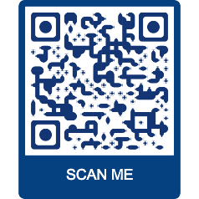
BRUBAKERBOOKS.COM…Your trusted source for aphasia and cognitive treatment materials for adults and adolescents.

