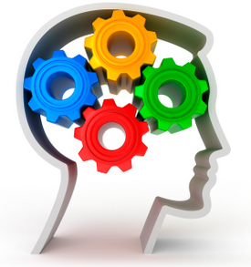
BRUBAKER BRAIN BOOSTERS

August is National Dog Month

…Recall the list in order
Most popular dog breeds:
Labrador Retriever, French Bulldog, German Shepherd,
Golden Retriever, Poodle

…Name 3 dog names every 30 minutes

…Follow these directions in order
Write the names of 5 famous dogs in alphabetical order and then write
their breeds in reverse order

For more tasks like this, see our product Flex Your Memory Cards

BRUBAKERBOOKS.COM
…Your trusted source for aphasia and cognitive treatment materials for adults and adolescents.
